# using mysql
# Question 2
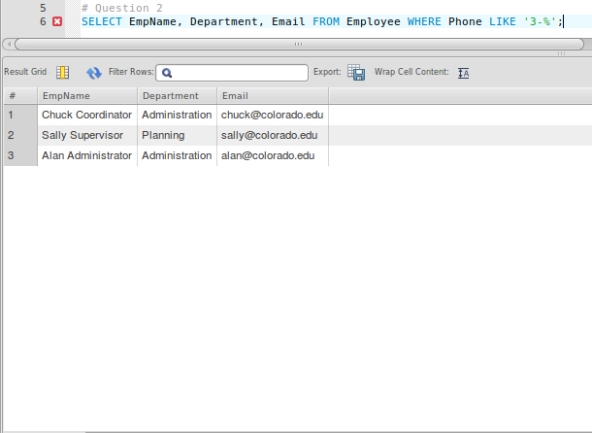
SELECT EmpName, Department, Email FROM Employee WHERE Phone LIKE '3-%';

